Since you are picking and placing merged boxes, I use same logic. I transport in a pattern of two boxes at one station, and request a need for a pattern of two products at another station. Since the boxes at the input/feed station are merged, they are considered 1 product at the receiving station. The goal is to have two rows of boxes fed downstream.
Here, robot picks and places two boxes but the location is not good. The robot is placing the boxes in pattern that uses default frame at the receiving station since the ProdID of the boxes, 111, has no teached/stored location at the station.
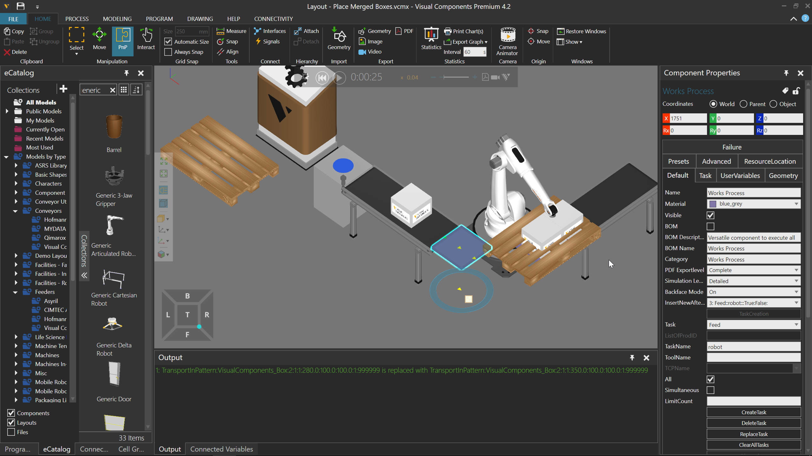

Here the StartRange and EndRange of TransportInPattern task is 1. That means only the first part in the pattern is needed to complete the task even though the amount specified in the task is two. I did this so I have one box at the receiving station, which I can use to position as the start of my place pattern.
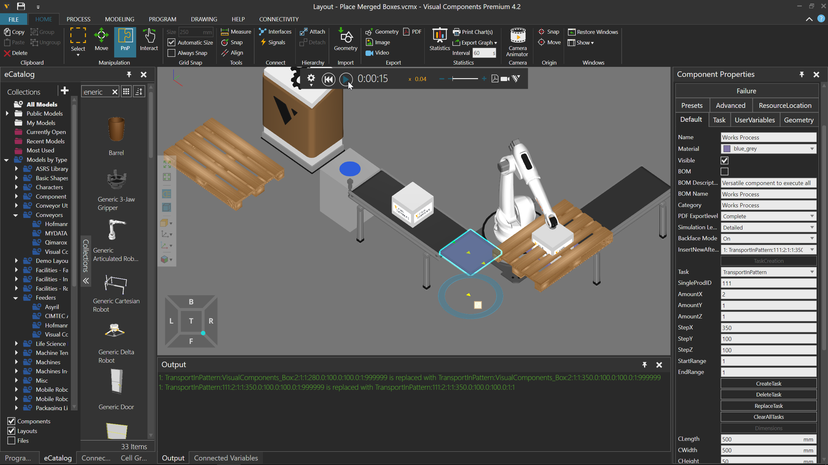
Location of box, ProdID of 111, is now stored.
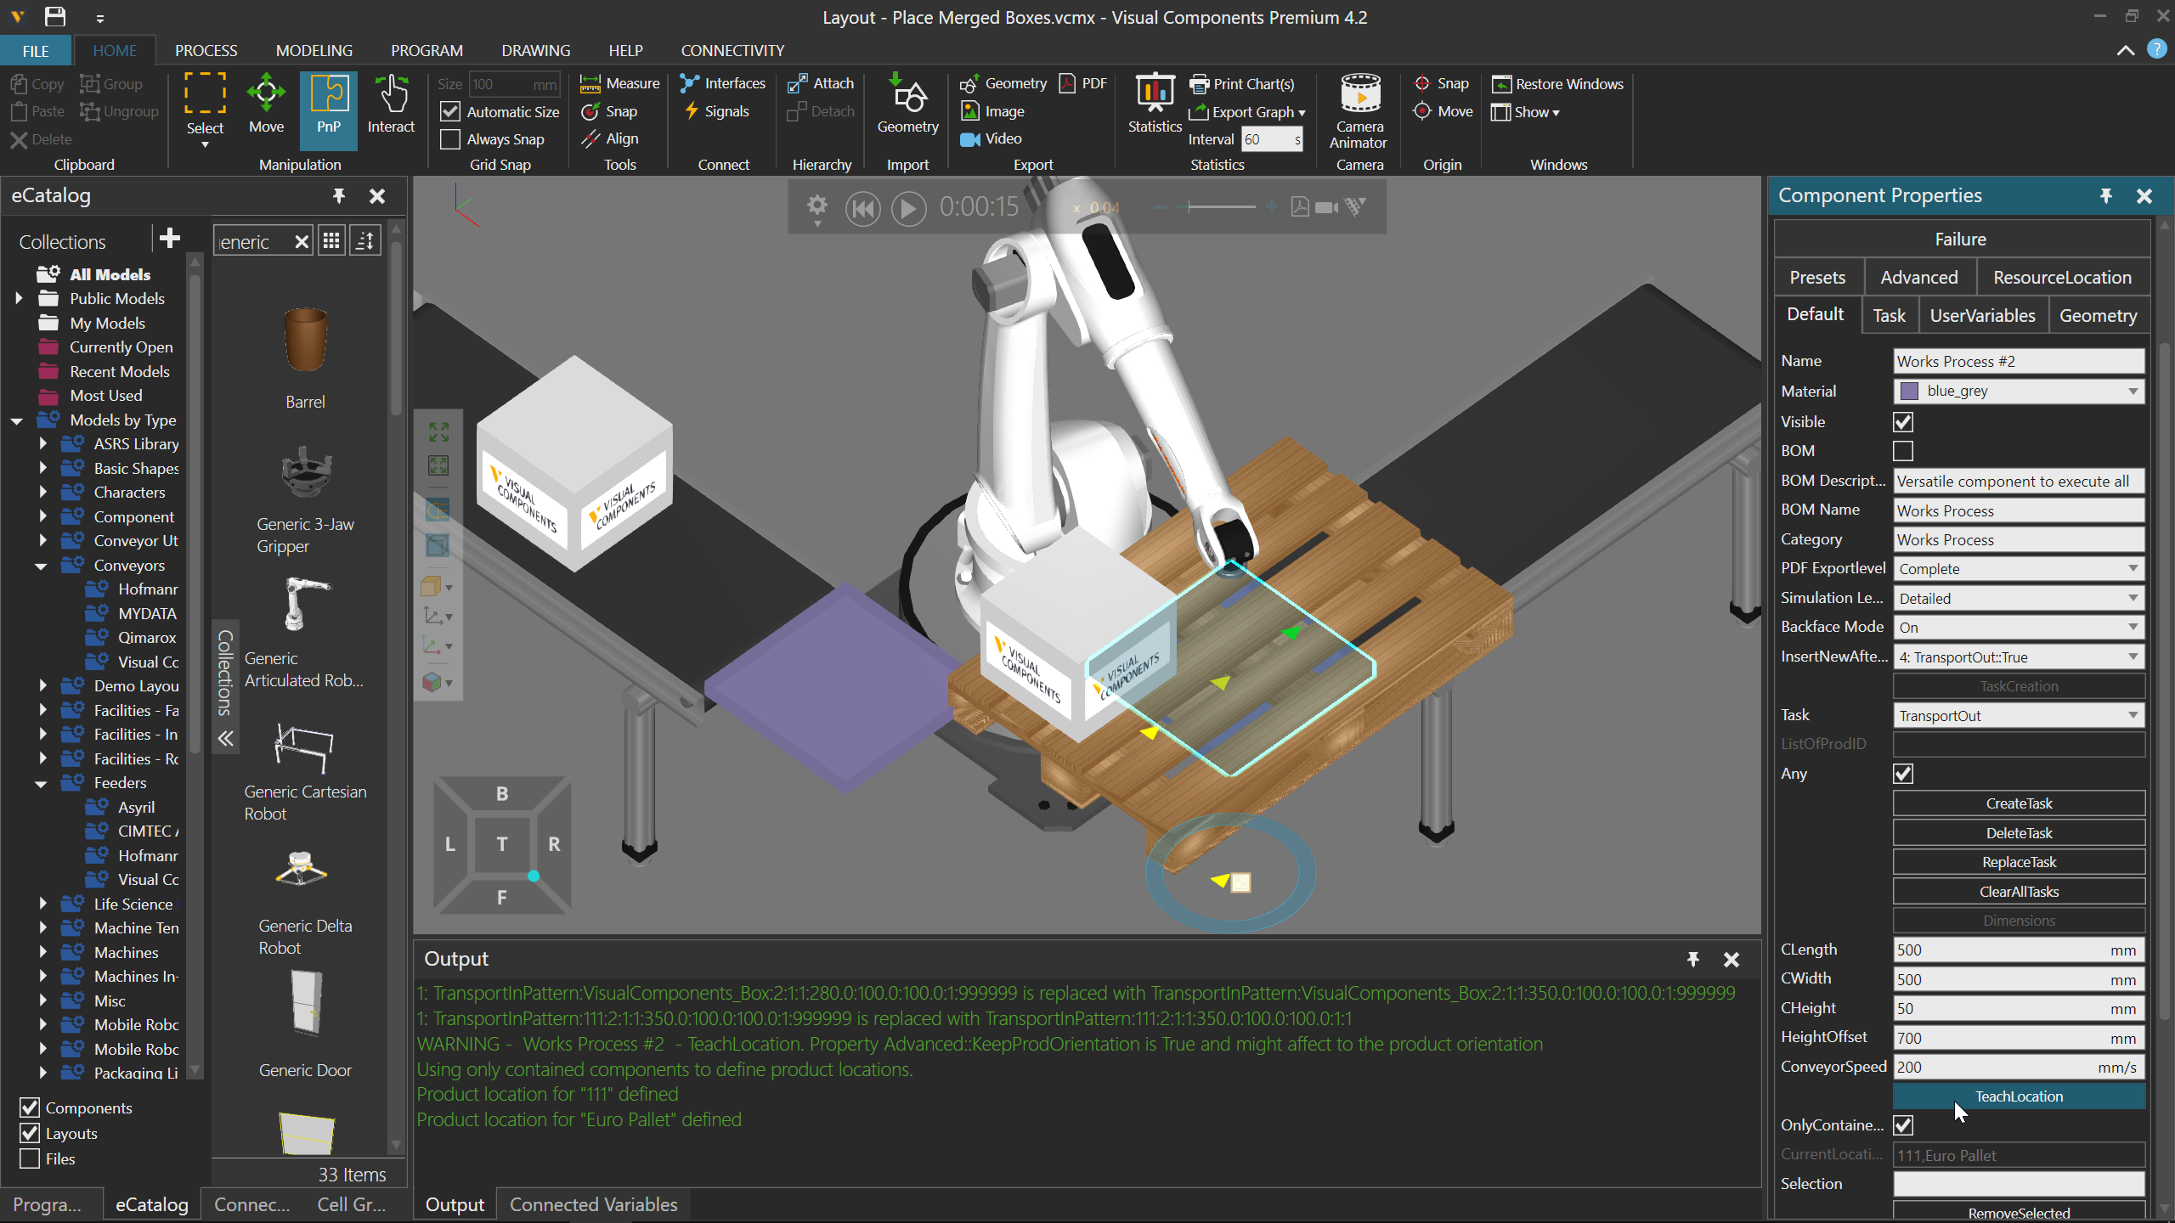

I set the EndRange of my TransportInPattern task to a value greater than or equal to the amount of the pattern. As a result, two boxes are transported in, merged together, picked by the robot, and then placed on the pallet starting from the stored location.
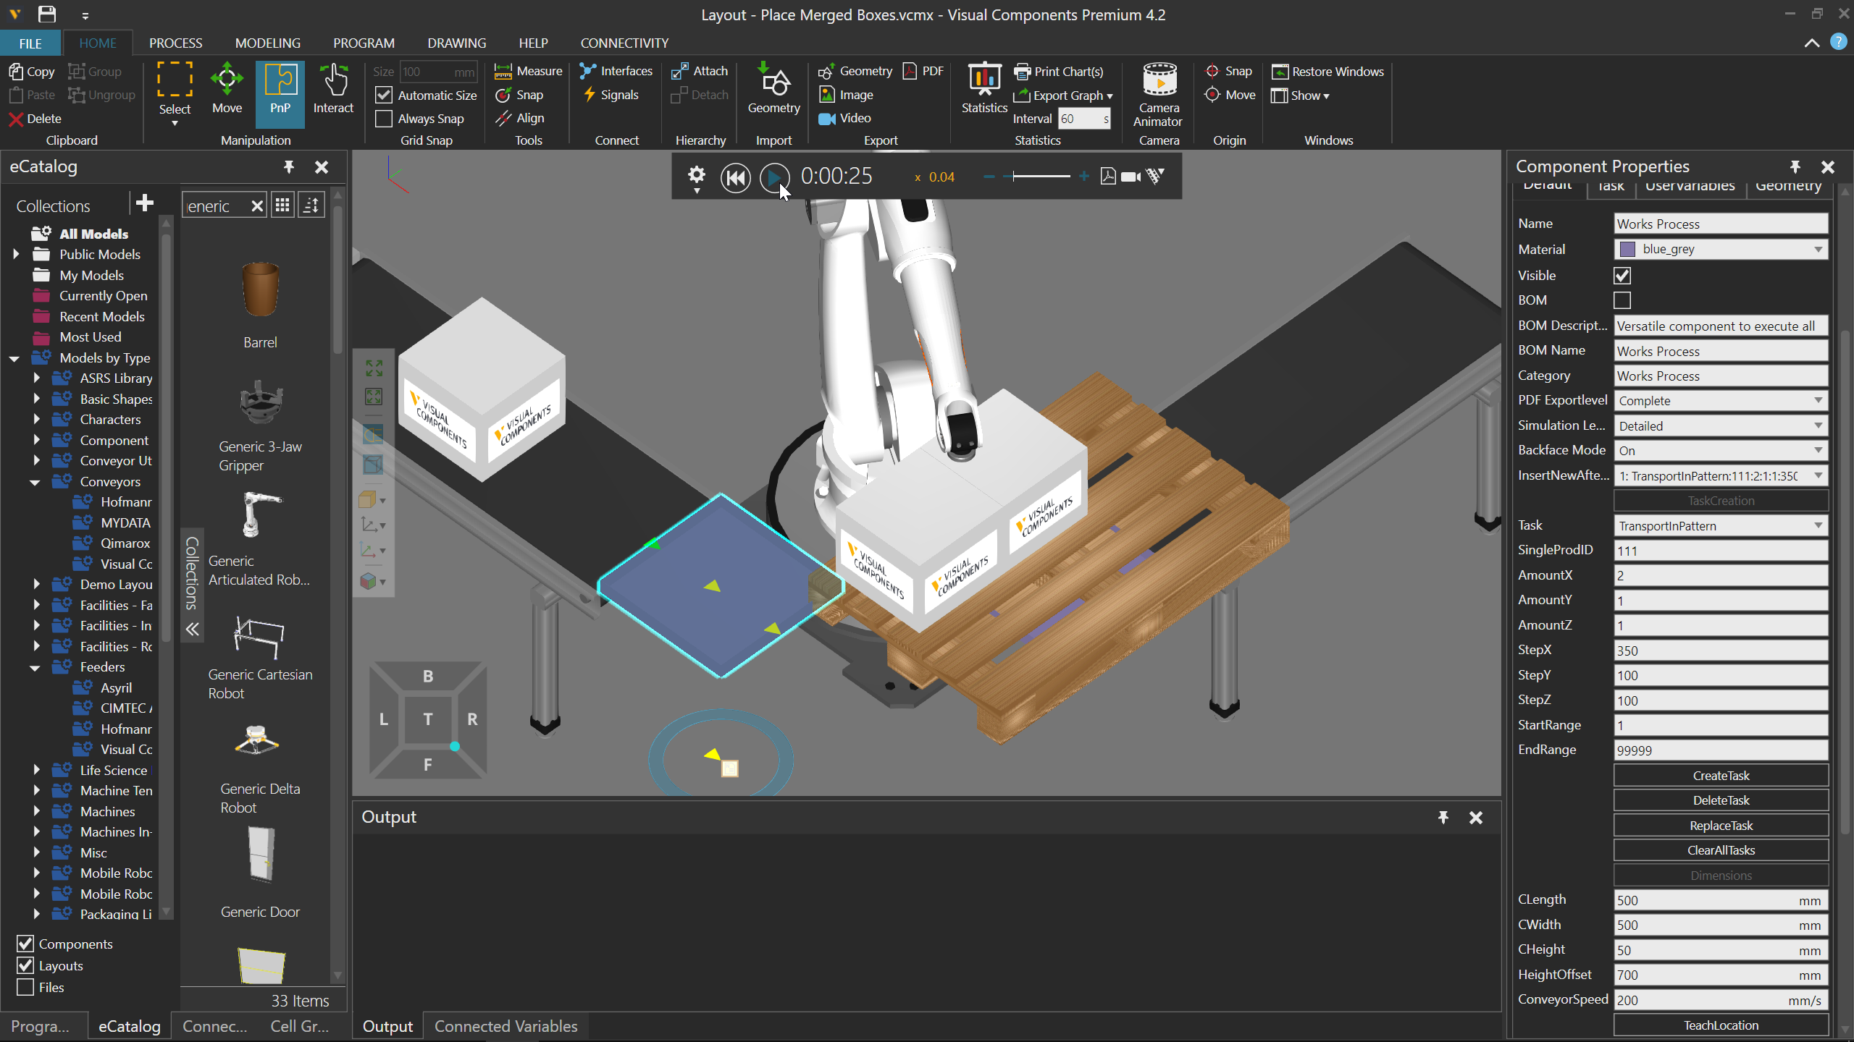

If I let the simulation run, I get the amount needed for my pattern but the position of the other row is not good. There are several ways to fix this. One way is to update the stored location for the box, ProdID of 111, at the receiving station, thereby affecting where the pattern starts. Another way is to edit the amount and step values of my needed pattern. In my case and for learning purposes for you, I will do both ways, but be aware there are multiple ways to address this issue.
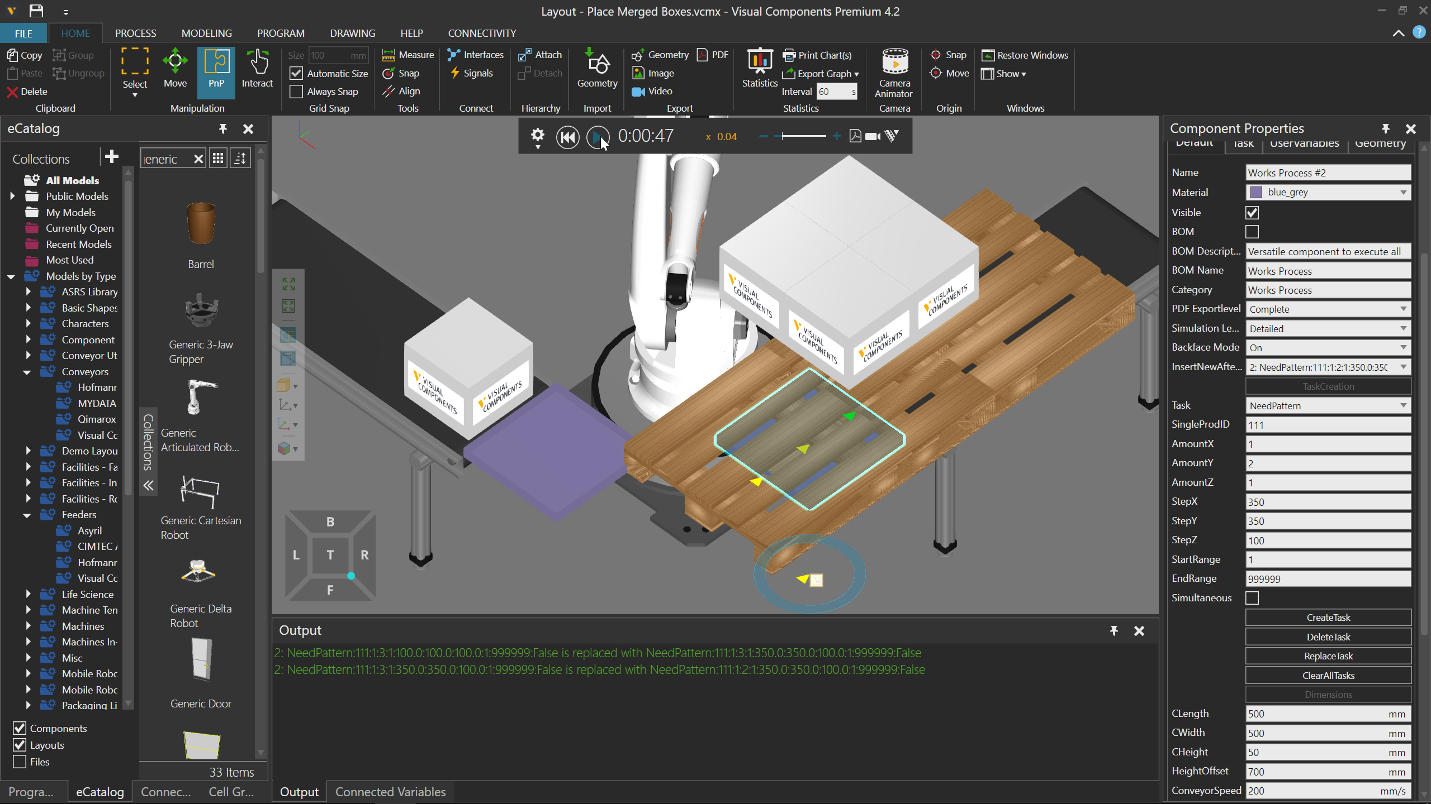

Here I do same thing again, but this time I rotate the box around Z-axis. This changes the orientation of the box’s, thereby affecting the pattern’s start position.
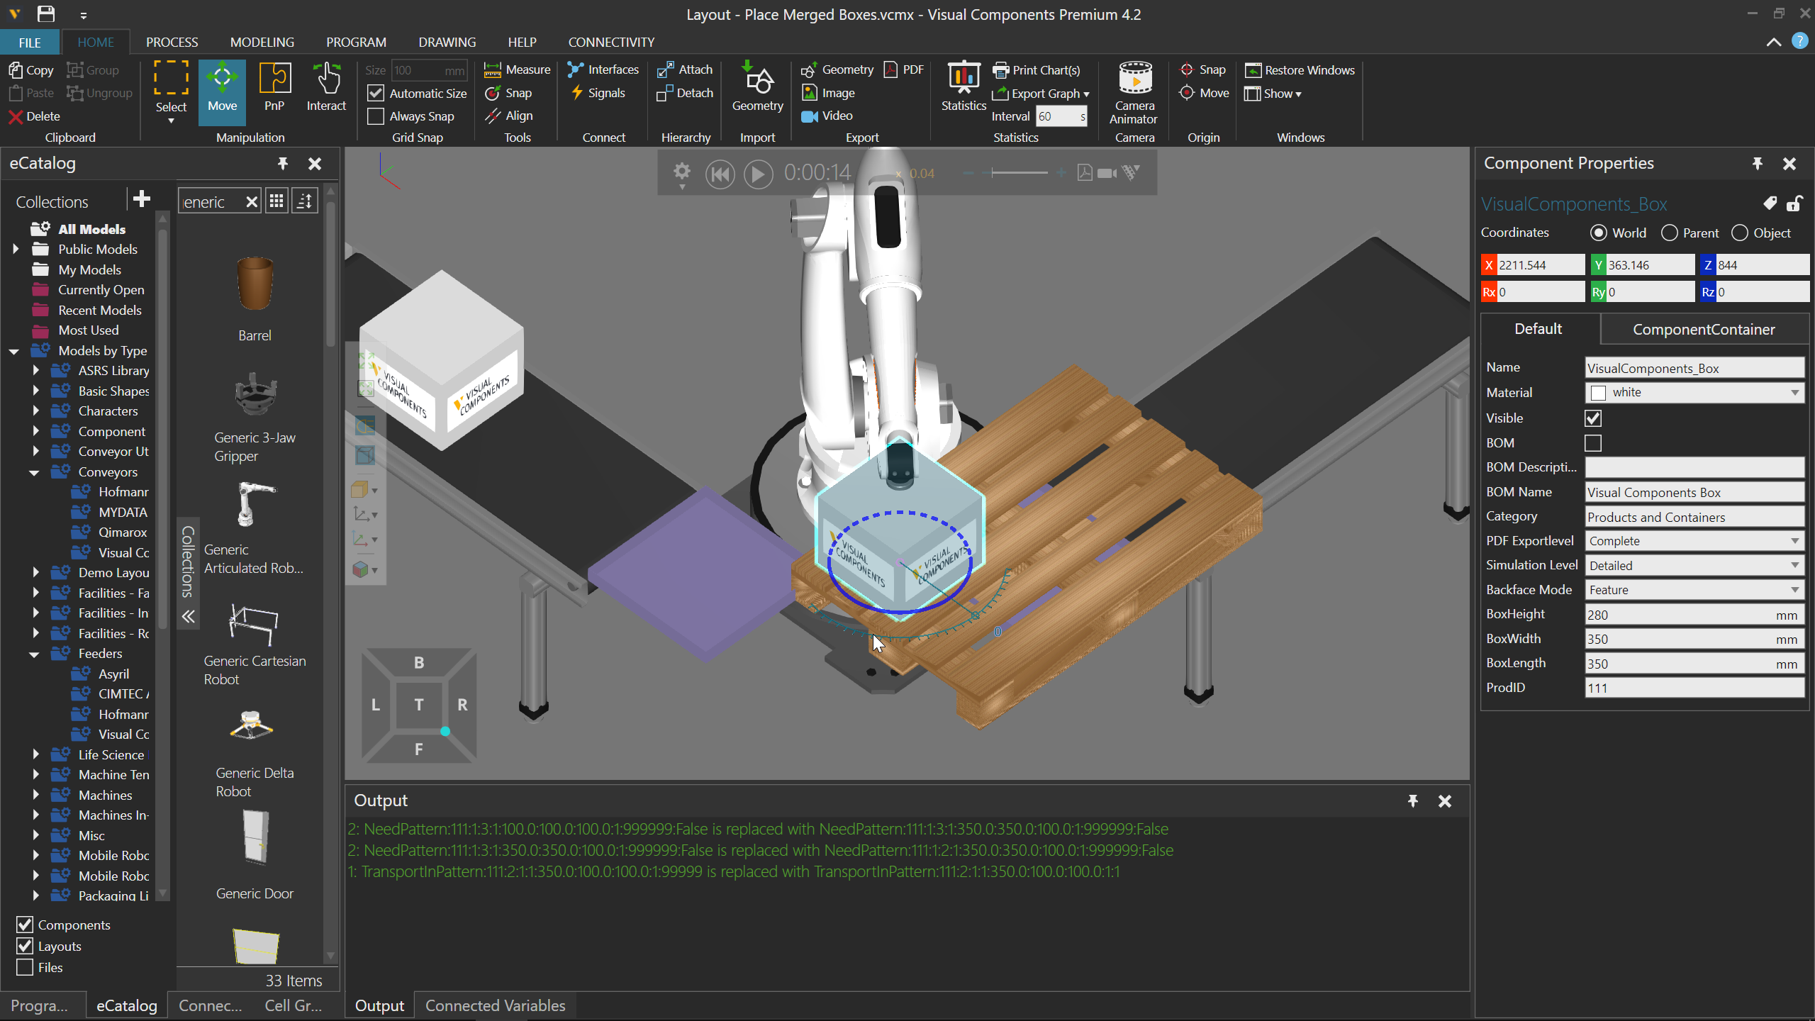
Result after updating the stored location
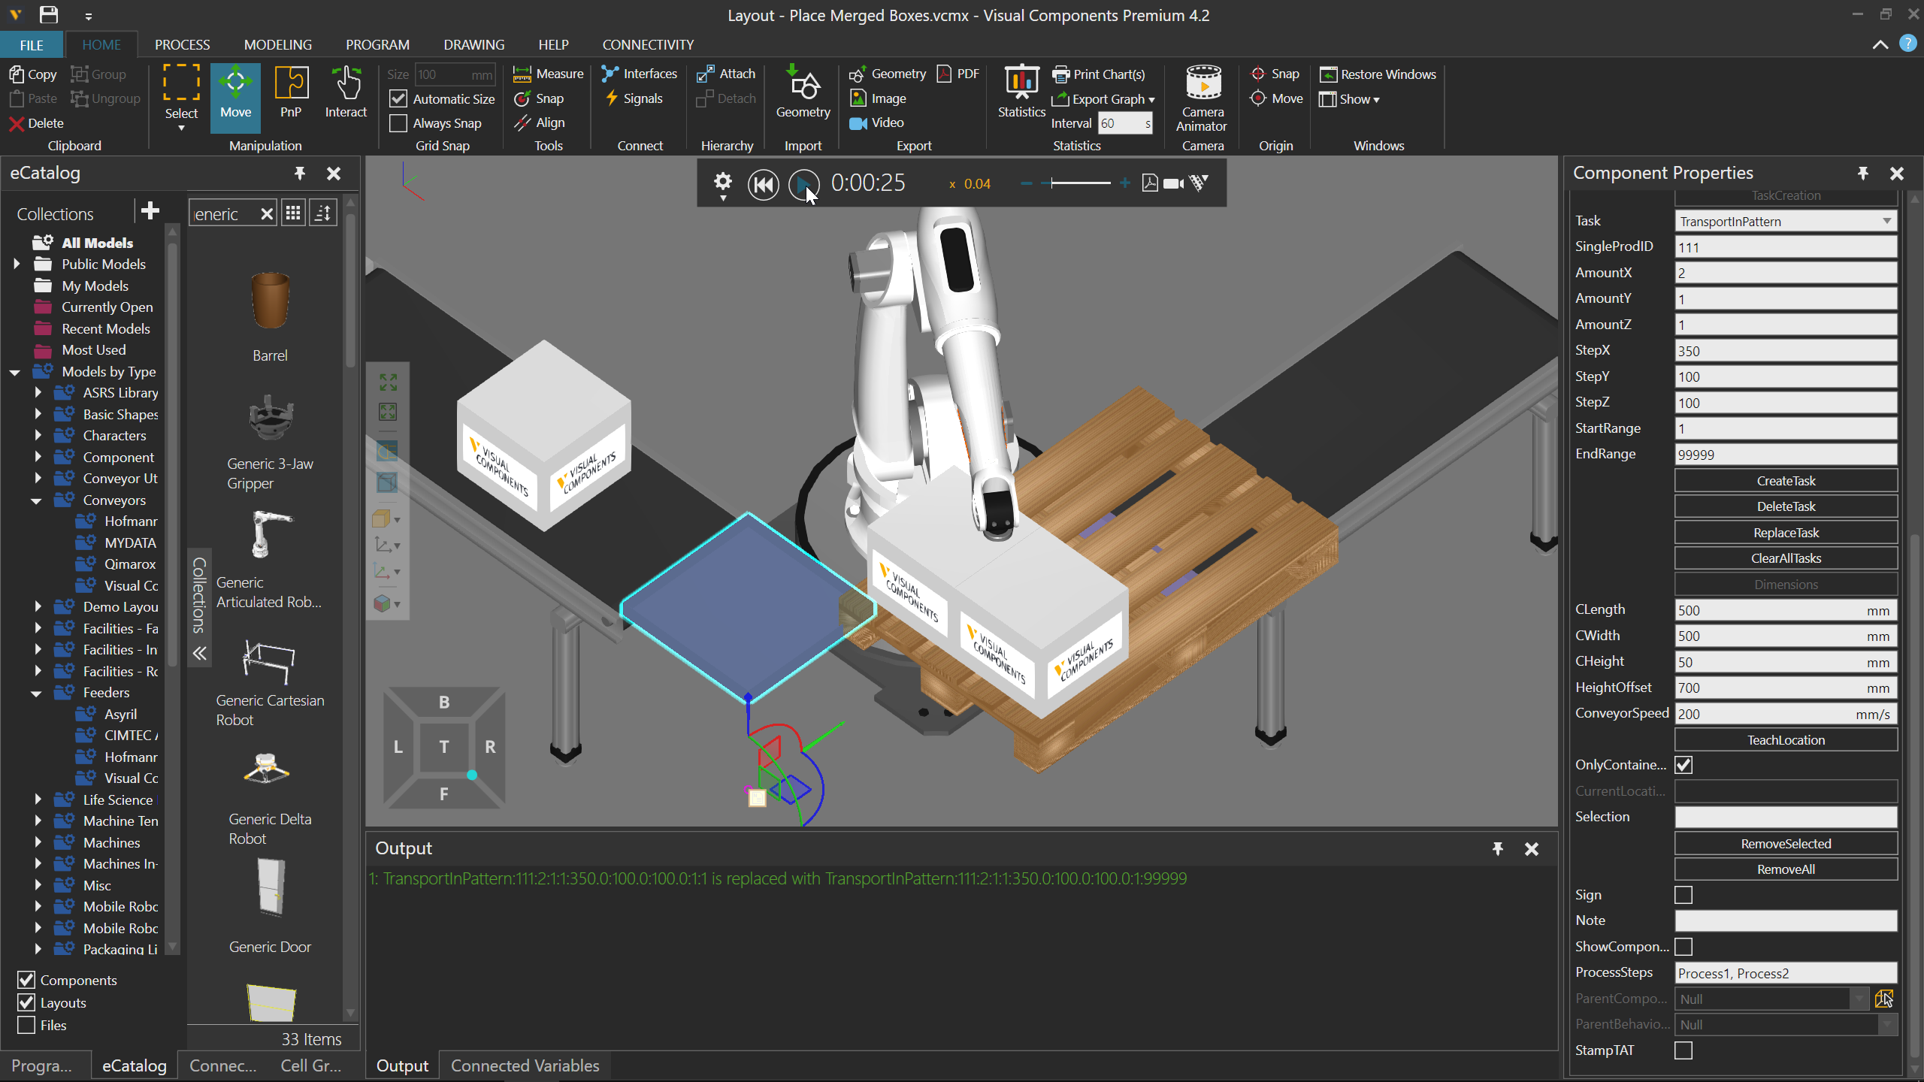

The boxes are still not placed properly.
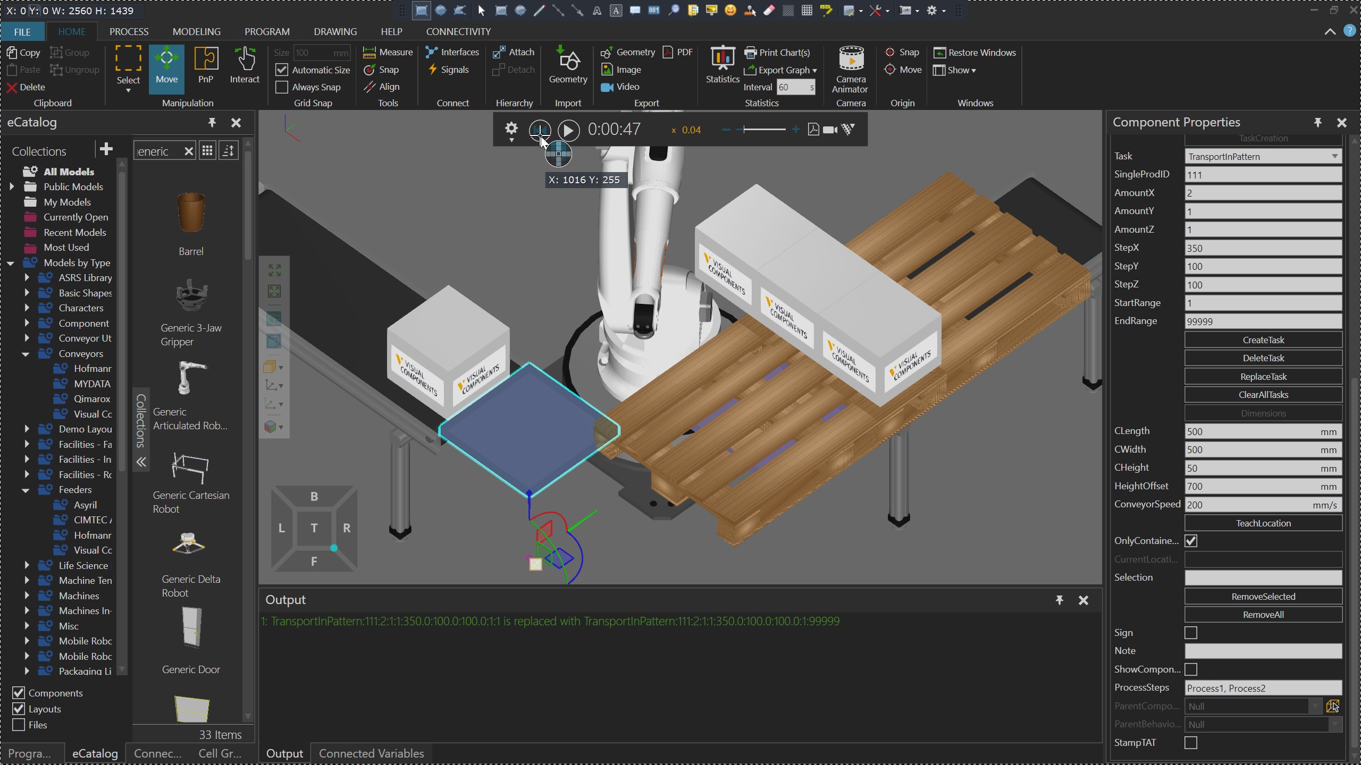
I need to adjust the NeedPattern attributes, but remember the direction of XYZ axes at the receiving station. In my case, I need to edit the pattern to have an amount of 2 going along X axis instead of Y axis. Why? Remember I rotated the box and updated its stored location, thereby affecting how the boxes are placed and the amounts needed in each axis.
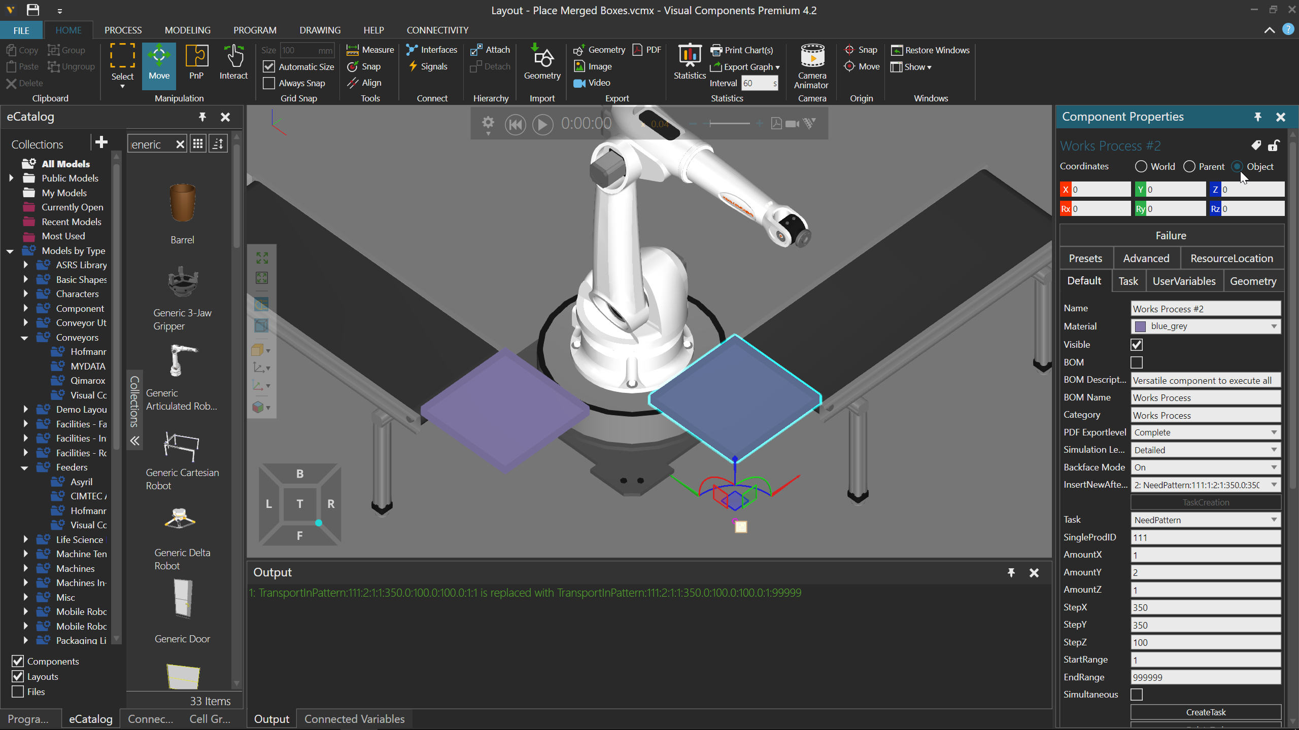
I just changed AmountY to 1 and AmountX to 2, and I have a solution.
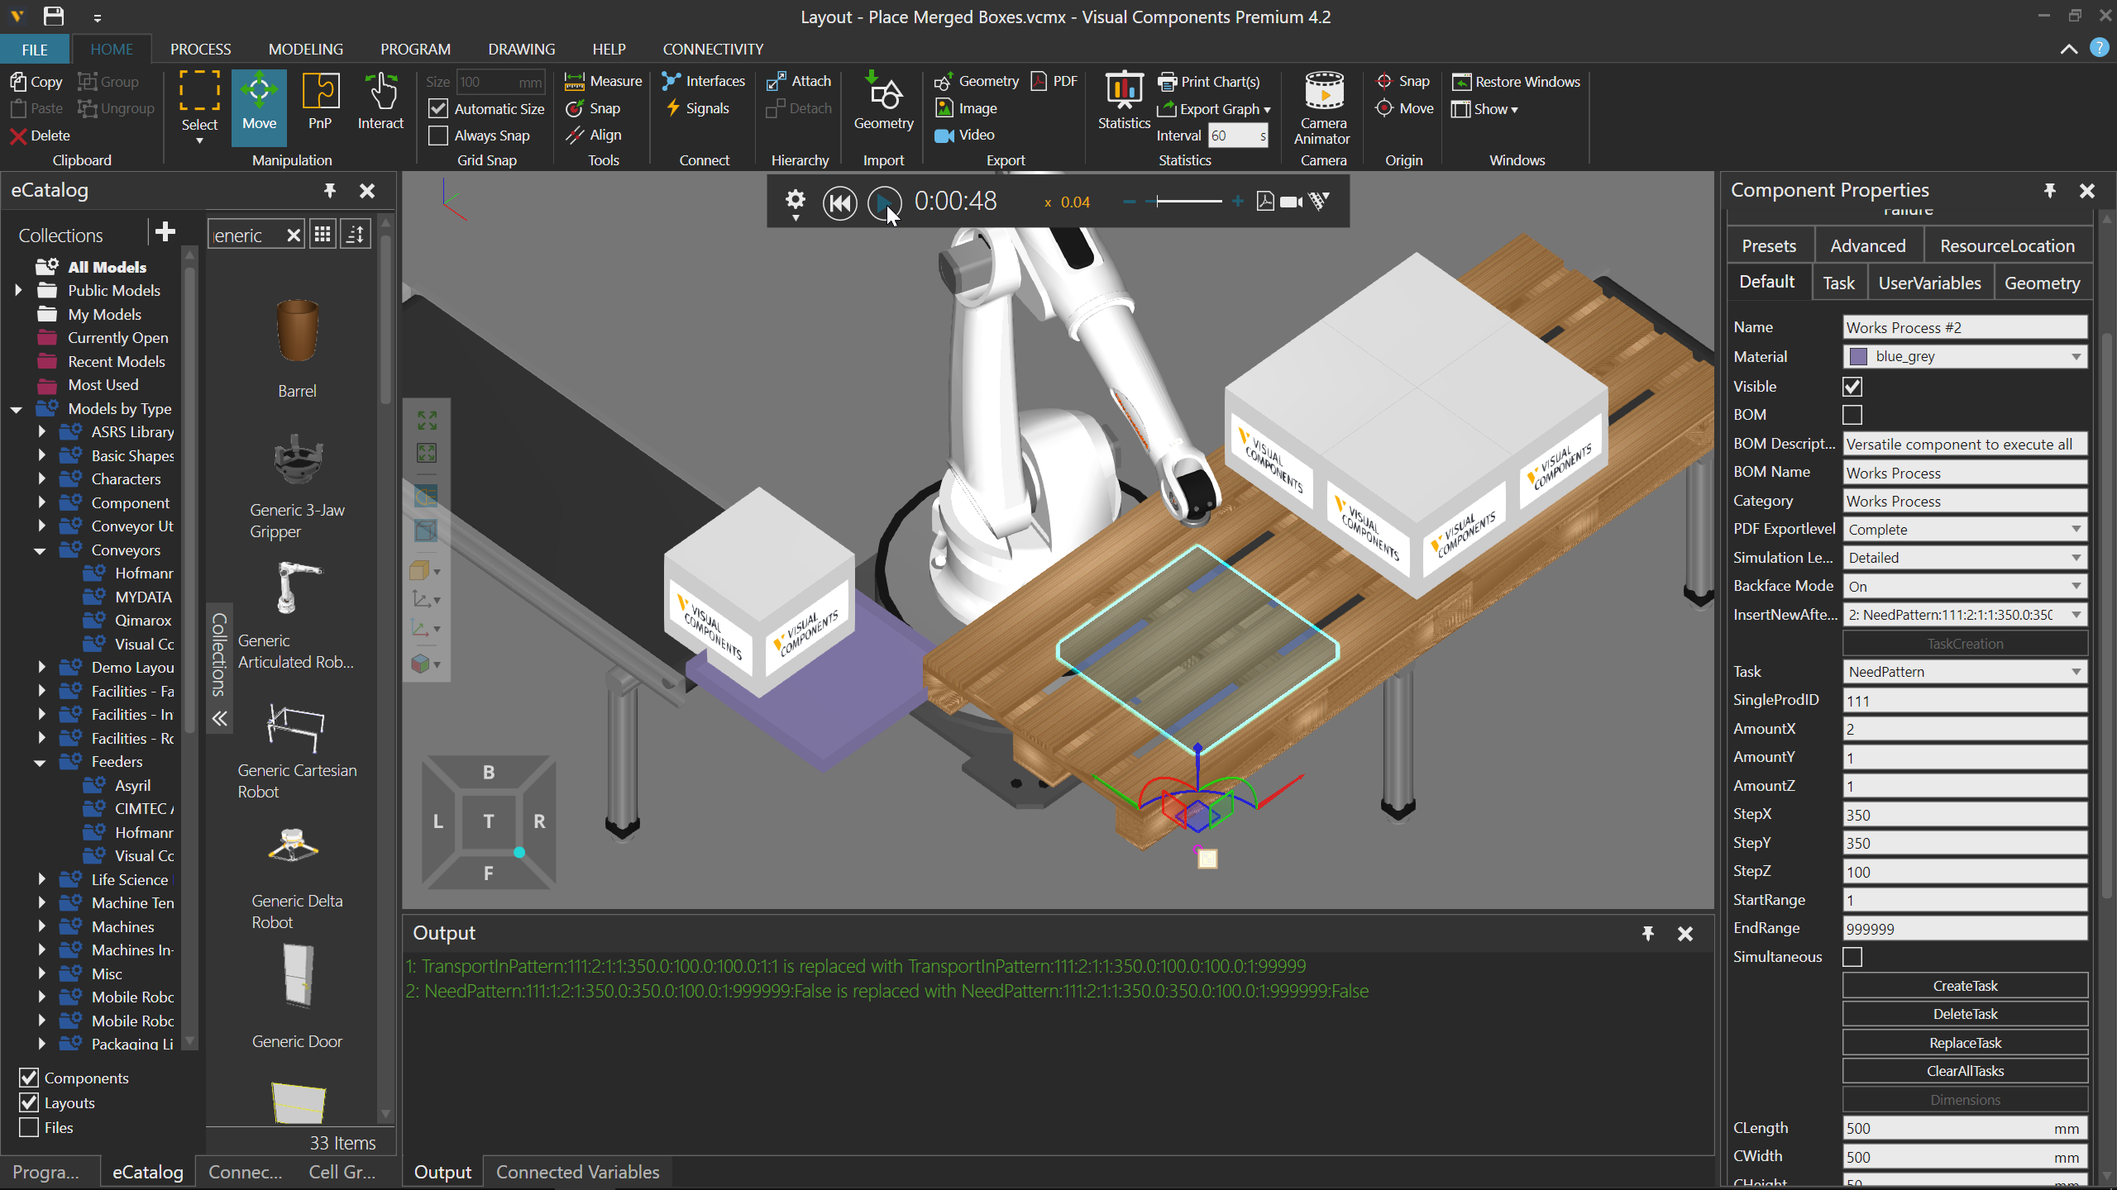
The solution is not ideal because the robot is not filling from the front/head of pallet. Instead the robot is filling from back/tail of pallet. I can change this in a couple of ways. One way is to make the step values for pattern be negative values.
